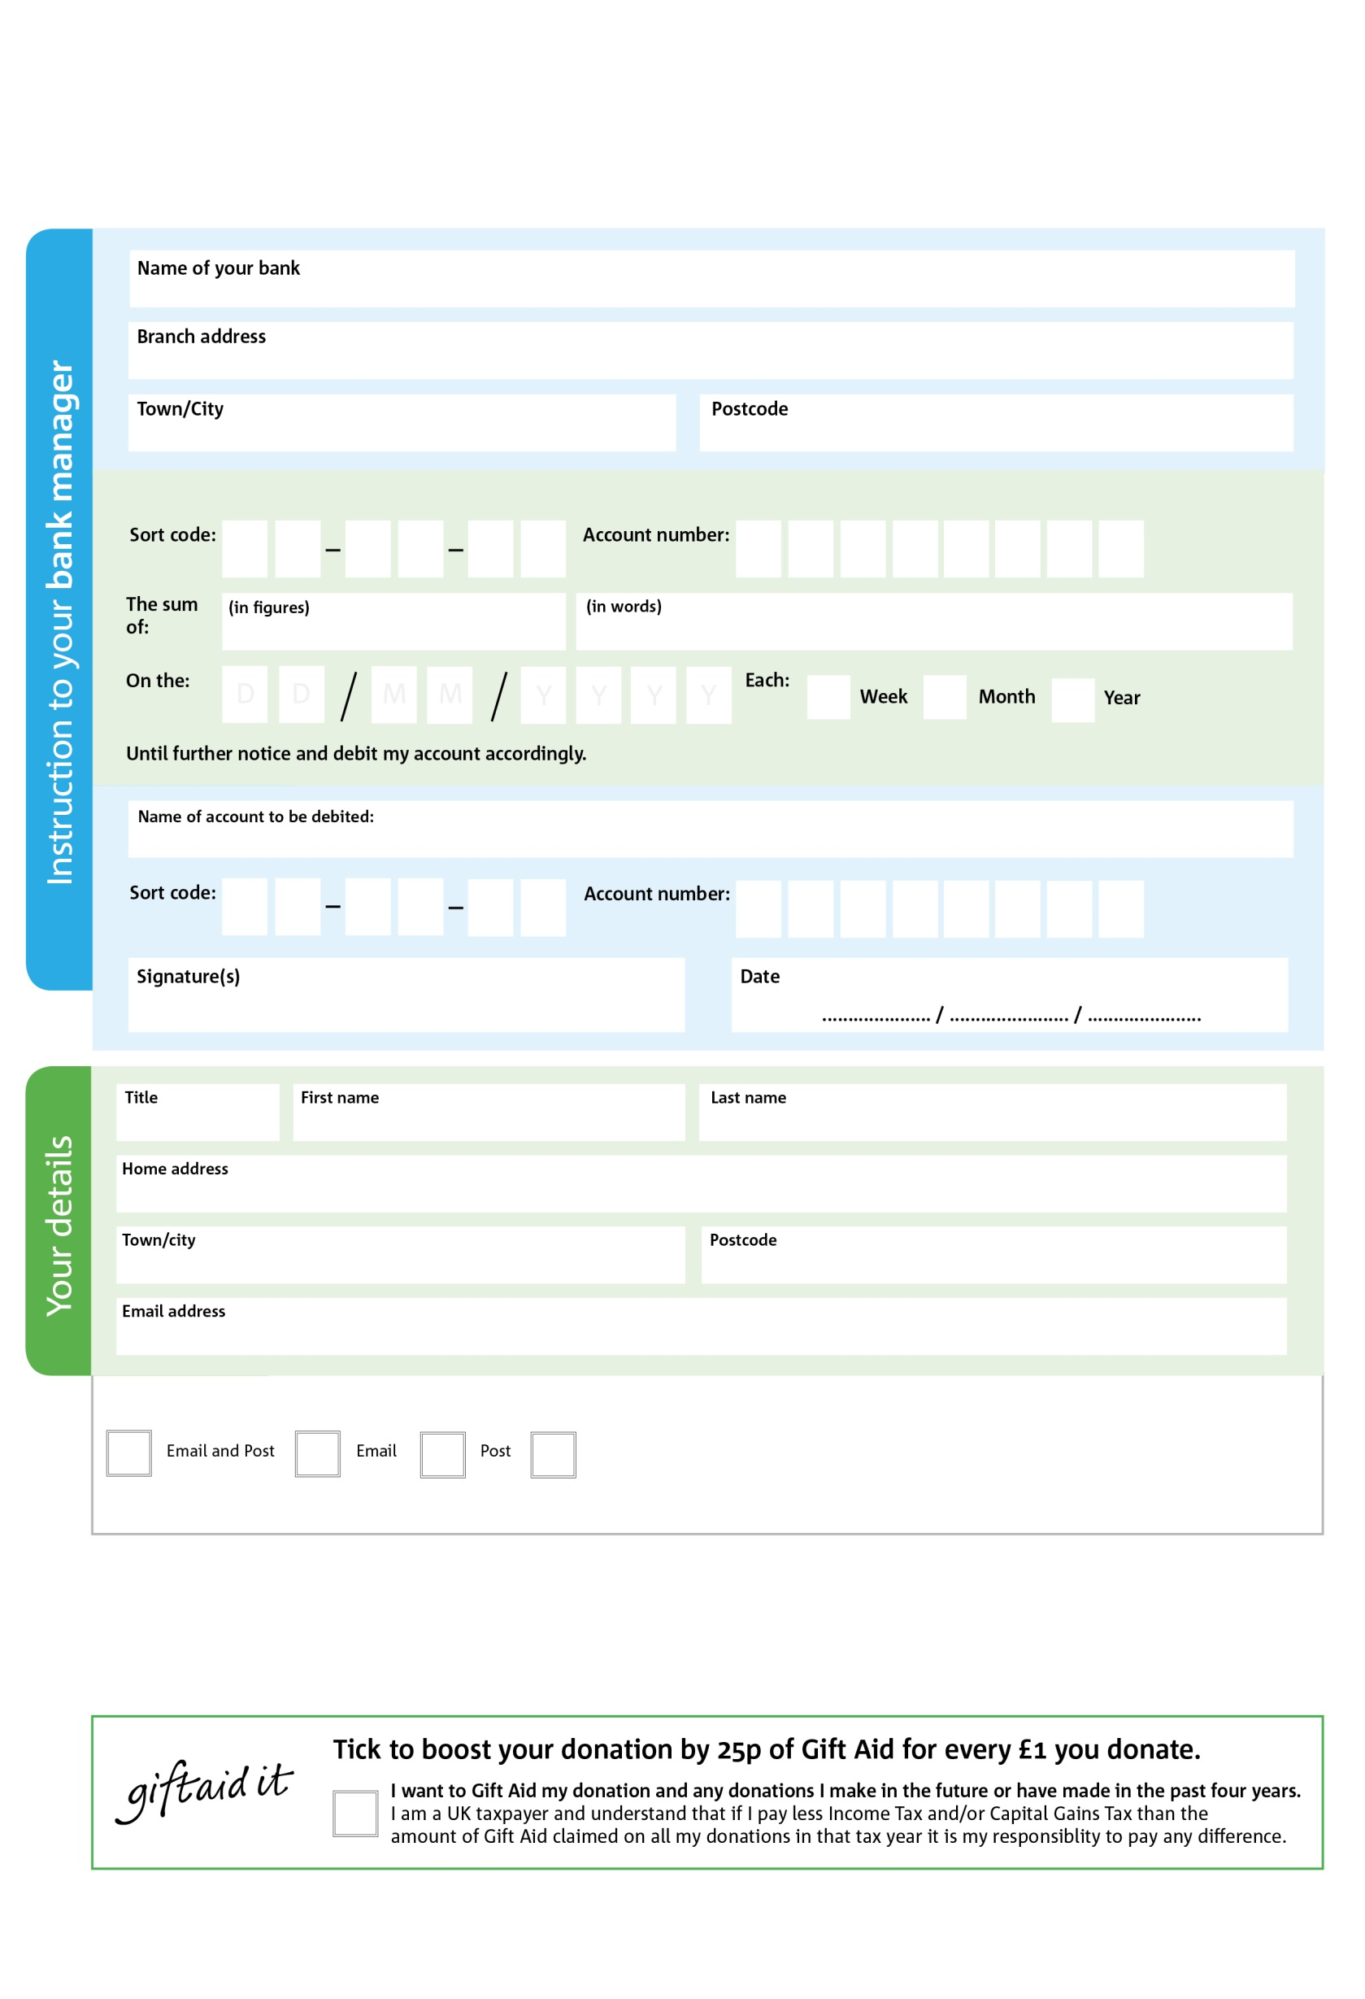

4

4 https://letchworth.foodbank.org.uk/wp-content/uploads/sites/70/2022/01/9.2.R1-Template-Standing-Order-Form.docx

4 https://letchworth.foodbank.org.uk/wp-content/uploads/sites/70/2022/01/9.2.R1-Template-Standing-Order-Form.docx

2

4 https://letchworth.foodbank.org.uk/wp-content/uploads/sites/70/2022/01/9.2.R1-Template-Standing-Order-Form.docx

POSTAL ADDRESS: Letchworth Foodbank, St Paul’s Church Office, 179 Pixmore Way, Letchworth Garden City, Herts., SG6 1QT

Reg. Charity No: 1197672 Reg. in England & Wales Wales

37

V

737

V77777

4

V44

57

V5

3

V3

0

V0

03

V0000

0

V

**Please pass this form onto the foodbank, using the foodbank’s address at the bottom, who will save a copy for their records.   
They will then send it onto your named bank or building society.**

0

4

2

5

0

We would love to keep you up to date with information about Letchworth Foodbank. Please tick your preference:

You can change your preferences any time by contacting us on 07825 300437 or emailing us at info@letchworth.foodbank.org.uk

I do not wish to receive future communications from XXXX Foodbank

Please pay Letchworth Foodbank,

**Data protection**

*'Letchworth Foodbank is committed to protecting your privacy and will process your personal data in accordance with current Data Protection legislation. Letchworth Foodbank collects information to keep in touch with you and supply you with information relating to our work. To unsubscribe from our newsletter, send a message to the email address above with the word unsubscribe in the subject line. A full data privacy statement for financial donors is available from the foodbank on request.’*

**Standing Order Mandate**

**letchworth.foodbank.org.uk**

You can change your preferences any time by contacting us on XXXXXXXXXXX or emailing us at XXXX@XXXXXXXXXX.foodbank.org.uk

I do not wish to receive future communications from XXXXXX Foodbank